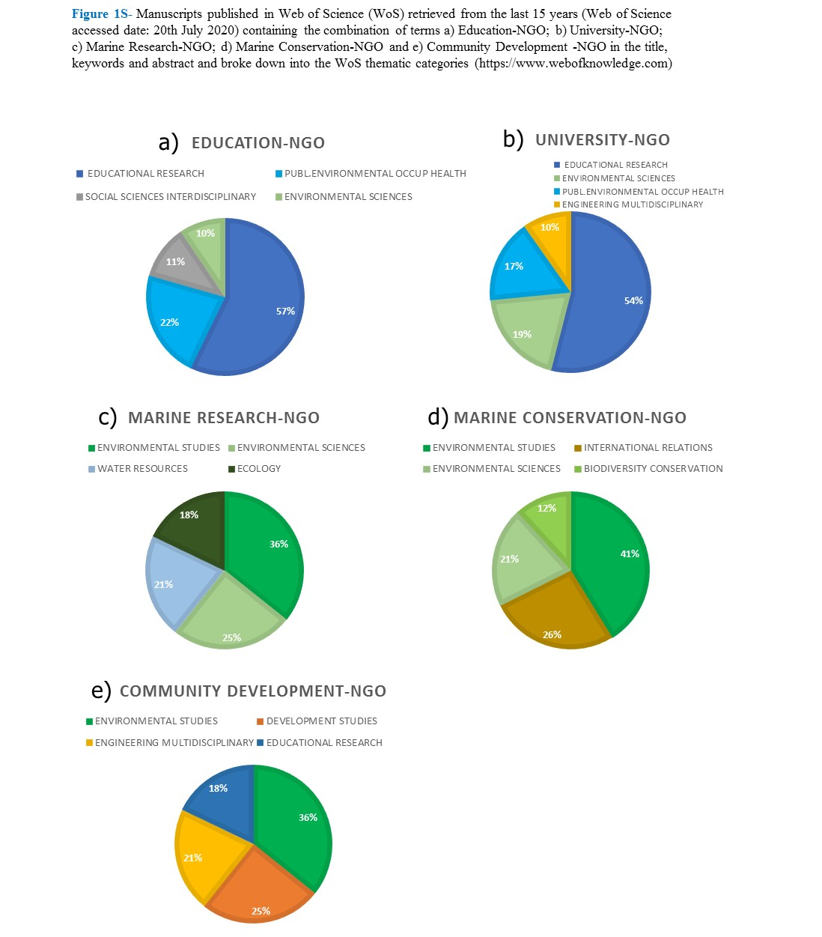

PEER REVIEWED MANUSCRIPTS

ORP has published six peer-reviewed manuscripts to date, that have involved 16 authors who belong to three NGOs, one private company and 11 research institutions (three of which are Higher Education Institutions (HEI), specifically Universities, and the other eight affiliating addresses are museums, research centres, and one aquarium). The 11 research institutes are based in the UK, and the rest are from 5 other countries (India, France, Oman, Maldives, Canada), which manifests the high level of international collaboration. Moreover, six peer-reviewed research reports have been published to date. Authors of these belong to two universities (University of Derby, UK and University of California, Irvine, USA), with the others working in the Maldives – in a Maldivian government-related research centre, a French non-profit organisation, an independent consultant, and in the Environmental Protection Agency.

ORP PEER-REVIEWED RESEARCH ARTICLES TO DATE (AUGUST 2020)

- Martin Stelfox, Alfred Burian, Kartik Shanker, Alan F. Rees, Claire Jean, Maia S. Willson, Nashwa Ahmed Manik, Michael Sweet “Tracing the origin of olive ridley turtles entangled in ghost nets in the Maldives: A phylogeographic assessment of populations at risk“. Biological Conservation, Volume 245, May 2020, 108499
- Martin Stelfox, Christophe Lett, Geraldine Reid, Graham Souch, Michael Sweet “Minimum drift times infer trajectories of ghost nets found in the Maldives“. Marine Pollution Bulletin, Volume 154, May 2020, 111037
- M. Stelfox, M. Bulling, M. Sweet “Untangling the origin of ghost gear within the Maldivian archipelago and its impact on olive ridley (Lepidochelys olivacea) populations“. Endangered Species Research. 10.3354/esr00990. (2019)
- Stelfox, Martin “Ghost Gear, The Silent Killers in Our Oceans“. Current Conservation Magazine Vol. 12 Issue 2, 2018:1 8-19
- Hudgins, Jillian and Emma, Ali, and Mancini “Citizen Science Surveys Elucidate Key Foraging and Nesting Habitat for Two Endangered Marine Turtle Species Within the Republic of Maldives“. Herpetology Notes, volume 10: 463-471 (2017)
- Stelfox, Martin, Jillian Hudgins, and Michael Sweet. “A review of ghost gear entanglement amongst marine mammals, reptiles and elasmobranchs.” Marine Pollution Bulletin 1.111 (2016): 6-17

ORP RESEARCH REPORTS REPORTS TO DATE (AUGUST 2020)

- Sweet, M; Stelfox, M. Lamb,J. (2019) “Plastics and shallow coral reefs. Synthesis of the science for policy-makers“. United Nations Environment Program Policy report.
- Stelfox, M. RHudgins JA Ali K Anderson RC (2015) “High mortality of Olive Ridley Turtles (Lepidochelys olivacea) in ghost nets in the central Indian Ocean.” BOBLME-2015-Ecology-14 (2015): 1-23.
- Stelfox, Martin “The impact of ghost nets on marine species in the Maldives“. IUCN Maldives Marine Newsletter Issue 3 January 2015: 13-14
- Stelfox, Martin “Ghost nets of the Indian Ocean – Olive Ridley Project“. IUCN Maldives Marine Newsletter Issue 2 August 2015: 18
- Hudgins, Ali, and Mancini “Marine Turtles of the Maldives: A field identification and conduct guide“. An IUCN Publication funded by USAID. (2017)
- Umaira Ahmed, Mariyam Shidha, Jillian Hudgins, Nashwa Manik, Enas Riyaz and Martin Stelfox in Citation: Phillott, A.D., and Rees, A.F. (Eds.) (2019). Sea Turtles in the Middle East and South Asia Region: MTSG Annual Regional Report 2019. Report of the IUCN-SSC Marine Turtle Specialist Group, 2019 (pp113-135) Online. (https://static1.squarespace.com/static/5e4c290978d00820618e0944/t/5e4d8cbead89174386a0b6c4/1582140611896/mtsg-regional-report-2019_-mesa.pdf)

EDUCATIONAL RESOURCES (TO AUGUST 2020)

Schools ─ The educational resources mobilised by ORP between 2013 and 2020 have reached an estimated 6,000 students from 34 international and national schools in five different countries (Maldives, Oman, Pakistan, Slovakia, and the UK).
Workshops and presentations ─ From its inception, ORP has conducted and led 18 workshops in eight different countries. Further, 41 presentations (seminar information sessions) have been given across 15 countries, involving the attendance of 6,187 people. The type of organisation hosting the workshops or seminars was very versatile, ranging through international symposia, GGGI, the United Nations, FAO, IUCN, public aquaria, WWF, universities, and a diverse number of resorts and rescue centres.

NUMBER OF STAFF DIRECTLY ENGAGED WITH ORP SINCE IT WAS FOUNDED (TO AUGUST 2020)

25 paid staff; 11 paid Maldivian interns; 6 trustees (volunteers); 2 celebrity ambassadors (volunteers); 97 volunteers (from 13 countries); 6 visiting veterinarian experts.

CIRCULAR ECONOMY (TO AUGUST 2020)

Pakistan ─ From a total of 4,280 kg of ghost gear collected in this country, a profit of GBP £1,866.34 for the fishing communities has been generated from June 2017 to June 2020, of which 93% of the total income (GBP £918.40) was raised by selling recycled dog leashes and bracelets. Other products created with ghost gear were donkey harnesses and jewellery.
Maldives ─ In two years (March 2018-March 2020), GBP £2,836.60 was raised by selling bracelets recycled from the collected ghost nets.

ONLINE PUBLIC ENGAGEMENT (TO AUGUST 2020)

Instagram (10,1K followers and 887 posts); Facebook (19,6K followers; more than 2,500 photos posted); YouTube (1,020 subscribers; 21 videos uploaded and 462,914 views); Twitter (1,4 K followers, 652 Tweets, and 274 photos and videos) (access date: 24th August 2020). Figure 3 exemplifies the clear increase along the years (2014-2019) in the engagement with the public articulated through the growing number of comments left in one of the ORP online platforms (ORP Facebook site).

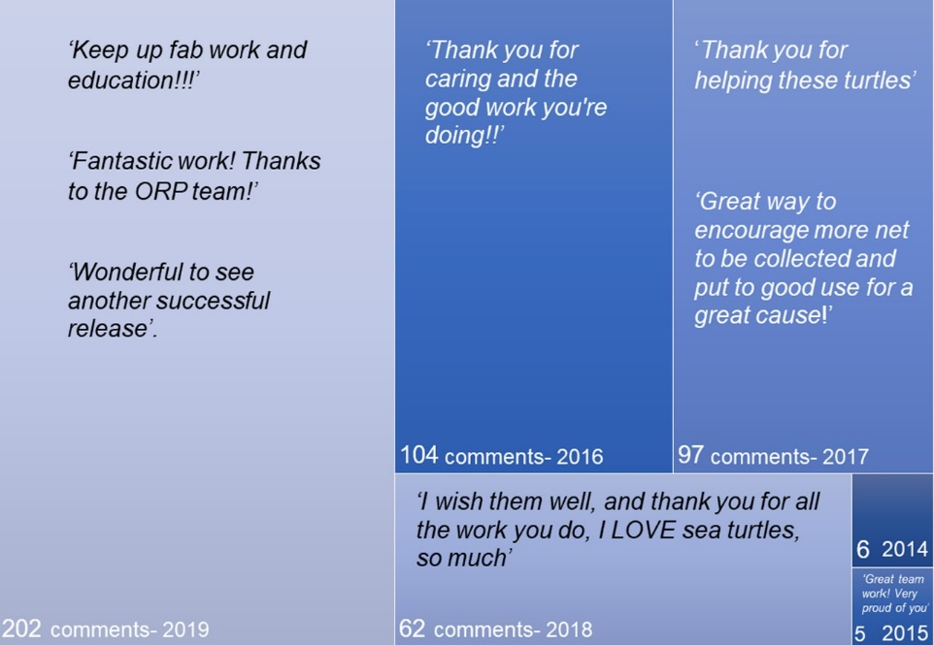
Figure 2S: Number of comments and some examples of them left in the ORP Facebook platform between 2014 and 2019 (https://www.facebook. com/OliveRidleyProject/)
ORP TESTIMONIES (in August 2020)
Question Your opinions on the research and work carried out by the ORP, how you are/were involved and how our research/work has affected/changed/benefitted your work and lives?

Answers retrieved through email to ORP CEO Dr. Martin Stelfox:

Laura – Turtle Biologist (Maldives)
“I was first involved with ORP when I was working as a Marine Biologist in the Maldives. My job was a lot more general, overseeing all aspects of marine life, however, I came across a considerable amount of olive ridley turtles entangled in ghost nets. From then on I was actively contacting ORP to try and give the turtles their best chance of survival. From building this wonderful repaw with ORP I was fortunate to be hired in overseeing the first ORP Rehabilitation Centre for sea turtles with minor injuries where they carry out their rehabilitation needs.

Working with ORP has opened my eyes to a lot with regards to conservation. I have been able to engage a variety of audiences from local school children, colleagues and resort guests. It is really rewarding to teach them all about the threats our sea turtles face, with them asking questions and how they can help. This is a small step to turtle conservation but as believed by ORP education is such an important factor to preserve marine life.

ORP is an incredible example of successful conservation due to its involvement with local communities and its outreach to wide audiences. I have gained an even deeper understanding about marine conservation and my passion has certainly deepened during my time with ORP. Seeing the sea turtles in the wild is also a real privilege and what we aspire for with sea turtle conservation. The looks on my guests and colleagues' faces when they see these magnificent and majestic creatures is priceless with so much excitement and admiration for the turtles. The most rewarding part of my job is to know you have saved and rehabilitated a turtle and can give it another chance to go back into the wild.

My life has been transformed from working with such a committed and passionate charity, working with a team that are all so dedicated to protecting sea turtles is such a privilege. It is my life goal to try and make a difference no matter how big or small to give back as there are so many threats facing our oceans. ORP has helped me to fulfil this need, and I look forward to continuing my journey in conservation”.

Jo – Turtle Biologist (Kenya)

“ORP’s work in Kenya is shedding an interesting light on the relatively unknown and little understood juvenile sea turtle lifestage on East Africa. Combining non-invasive capture-mark-recapture methods such as photo identification not only has been allowing us to identify a relative large juvenile green turtle population in the south of Kenya, but also understand sea turtle distribution and habitat needs. Our work is essential for instance to the establishment of baseline data on sea turtle abundance and distribution in the planned marine protected areas around Diani, Chale Island and Tiwi, located south of Mombasa. On the other hand, the growing involvement of the civil society in recording sea turtle sightings in contributing with data (13% of all data on the Diani database), shows the great potential of using citizen science to expand and increase our knowledge about sea turtles. Moreover, the training and involvement of Kenyan marine biologists, all female, has been praised for being empowering and inspiring but other conservation groups, research institutions and dive centres. As an experienced sea turtle biologist with no previous work experience in East Africa, this project has shown many of the potential research and conservation work that can be done not only in Kenya but the whole region, as many gaps have been identified, especially regarding the study of juvenile populations. Facing the hard reality of a huge problem of by-catch in the artisanal fisheries, habitat disturbance and minor conflicts not only between communities and entities related to marine conservation and communities, as well as between the entities as well, sea turtle conservation in Kenya faces great challenges that can only be addressed by collaboration and community involvement”.

Kristina – Turtle Biologist (Maldives)

“As a Sea Turtle Biologist for the Olive Ridley Project stationed in the Lhaviyani atoll, I managed a number of regional databases including the photo ID, nesting and entanglement database. In previous positions I collected photo ID data on sharks and cetaceans and was now able to extent my experience by using the method on turtles. The experience working with marine turtles equips we with a skill set which will benefit me in becoming a more diverse marine biologist and conservationist. A main part of the work was the interaction with the resort guests, which in my opinion was equally as important as the data collection. By educating the guests about the turtles’ biology and conservation we received lots of positive feedback and donations important to sustain our work. One interaction sticks out. A sales manager of a global fishing company approached me after hearing about the Olive Ridley Project and the ghost net entanglement issue in the Indian Ocean. For the first time he was reflecting on the impact of his line of work on the marine ecosystems and we had a long fruitful discussion. I am therefore convinced that the approach of the Olive Ridley Project by including the resort guests in the conservation question is valuable and is able to bring about change within the tourism sector and even in the fishing industry. By using citizen scientists, we further the educational impact and the experience of the guests will be a lifelong memory which will hopefully influence their behaviour and choices.
The results of the ghost net and entanglement research are of global importance and I believe the Olive Ridley Project has been a big contributor to bring awareness to the issue. We have taken a leading role in the fight against ghost gear, which hasn’t received as much attention and research funding as the issue of plastic pollution by single use plastics. By our ongoing research we will have a major impact in the conservation of sea turtles in the Indian Ocean and global ghost gear research”
Asif Baloch – Pakistan -Infield coordinator (Fisher)
“Before ORP the people in the village did not know how harmful the nets in the ocean were. We were unaware of the dangers to marine life they cause and subsequently harm our livelihood as well. The research work of ORP and its explanation of its importance to the villagers have enabled us to understand the sea and our relationship better. How we can live in harmony with the sea and sea life with our modern fishing equipment. ORP's research has taught us how not harm our changing relationship with the sea beyond repair.

I am involved in removing ghost nets from the beach and the sea. The villagers alert me of a beached or lost net and I remove it from the environment, wash it, clean it and store it. Later on we use the nets in making bracelets, jewellery, dog leashes etc. I also help the women in the village in making these items which sell and they get an additional income from it.

Working with ORP I have learned more about how our actions affect many other creatures in the ocean as well. That we must not leave our trash in the sea but remove it from every environment as in the end we suffer as well. Personally, I have benefitted as working with ORP has opened more opportunities for me besides fishing and being a lifeguard. My younger brother who works with me and ORP gets to learn and interact with people, which will benefit him professionally later in life.
My brother and I both got our SCUBA diving license because of ORP. With ORP I get my message of a cleaner ocean to many people across the city and hopefully the country”

Rushan - Spatial Ecologist (Singapore)

“The main research we’re carrying out is the spatial ecology of rehabilitated Olive Ridley turtles coming out of the rehabilitation centre. My main roles in this project is to spearhead it. At the moment, we’re still trying to source funds, but I’ll be tagging sea turtles before releasing them and doing any necessary training on tagging turtles as I can’t be in the Maldives all the time. After that, I’ll be managing and analyzing the data and preparing manuscripts for publication.

I don’t think I would have had this opportunity anywhere else. It certainly helps that I knew Martin from my short time in the Maldives, but I feel that the structure of ORP (being open and flexible) along with being founded in scientific rigor is the perfect combination for me to do this important work in the Indian Ocean”.

Jill – Senior Project Scientist (Canada)

“"I'm proud to have been a part of the Olive Ridley Project as Senior Project Scientist since it's inception. I head up our sea turtle photo identification project and oversee data collection on nesting, ghost gear recovery, and stranded sea turtles. Over the last several years ORP has made great strides, expanding projects into new countries around the Indian Ocean to tackle turtle conservation and the threat of ghost gear.

I chose to pursue the marine biology/conservation field of science based on my love of the natural world and my desire to help mitigate the threats that animals and their habitats are facing. The work that ORP is doing on the ground every day is directly mitigating those threats, protecting vulnerable sea turtles, and making a real difference in coastal fishing communities. Working with ORP has helped me learn, grow, and adapt to challenges as a scientist and it is a pleasure to work with such a global, passionate team of like-minded people."

Claire Lomas – Vet – Maldives

“I worked at the Sea turtle rehabilitation centre in Maldives and helped rescue and rehabilitate injured sea turtles. Working at the centre opened my eyes to the vast problem of ghost gear and threats faced by sea turtles in the wild. Working with ORP showed me the various ways this problem can be tackled and taught me that it is important to have multiple approaches to a conservation problem. Rescuing injured turtles was incredibly rewarding work but I loved that the charity also tackled the wider picture of reducing the problem of ghost gear through removal, education and research. Many conservation projects I had encountered in the past only looked at one side of the problem.
The work has deeply affected my life and goals. Since working with ORP I am much more conscious of my own impacts on the environment. Working with ORP has increased my awareness on how humans affect the environment and ocean. For example, I was not aware of the large impact that the fashion and clothing industry has on ocean plastic, being a large contributor to microplastics in the ocean. Working with ORP and learning from members of the team has caused me to further change my own habits in life and spread this knowledge to new people that I meet”.

Ibrahim Shameel – Project Coordinator (Maldives)

“I joined in with ORP for the post of the Project Coordinator in December 2016. I have been part of the team ever since , primarily working on expanding ORP's presence in the Maldives through outreach sessions as well as leading Sea Turtle Expeditions which was a project developed in 2017. For me personally, my experience with ORP has been very fulfilling and a great learning experience. The guidance and training i have received from ORP has allowed me to carry out my job well. I have been able to directly contribute to on-going research of assessing the sea turtle population in the Maldives and the long term data collection of drifting ghost nets in the Maldives via our sea turtle expeditions. I have also gotten the opportunity to explore the Maldives from a different perspective, as my work with ORP has allowed me to travel to different parts of the Maldives and experiencing the different cultures from the nothern and southern regions of the Maldives.
Irthisham Hassan Zareer (Iru) – Expedition Leader (Maldives)

“I initially got involved with the Olive Ridley Project through Shameel, who also happens to be a dear friend and a colleague through the Maldives Whale Shark Research Programme. When he had offered the chance to join the 3rd sea turtle expedition to Haa Alif atoll, I was beyond excited. I had not worked with turtles before and I was really looking forward to that. The location of the expedition had made it all the more special as it was also home for me. The expedition experience was a great learning experience. It opened my eyes to the extent of the ghost net problems facing the Maldives. Especially in the North where we were based. Before then, I had never seen as many ghost nets in such a short period of time. Luckily there were no entangled animals but it definitely left an impact. Especially when I ponder on all the ones might have passed through unseen, tangling everything in its wake with their death grips. I admire the work Olive Ridley Project is doing on these and will definitely be helping whenever possible with ghost net data collection”.

Farah Amjad – Expedition leader (Maldives)

“I was involved with ORP working as an Expedition Leader during their Kelaa expedition in July 2019. Having mostly worked in environmental consultancy, I was looking for an opportunity to get more involved in marine conservation projects and the expedition provided just that. Working on a remote island, coordinating survey trips and handling other aspects to research than just data collection was something new for me and it helped me gain confidence to work more independently in the field. I have moved onto explore more work/studies related to marine conservation and have started my graduate program in Marine Sciences”.

Claire Petros – Vet (Maldives)

“I have been involved with ORP since November 2016. I was hired as the first veterinarian and my role was initially to set up the marine turtle rescue centre and veterinary facilities. I lived on the island of Coco Palm Dhuni Kolhu and over the space of almost a year set up the veterinary clinic so that operations and rescues could be medically and surgically managed in the Maldives. This was the first veterinary clinic in the country. During this time I was mainly performing surgeries on the entangled turtles but I also collected data for research, such as DNA samples of the sea turtles and parasite samples, such as marine leeches.

Being part of the Olive Ridley Project charity has set me on a path in to sea turtle conservation in a unique way; having had field experience as a sea turtle vet in the Indian Ocean has created many wonderful opportunities. Through representing the work of the charity, specifically the rescue centre, it has resulted in speaking at international conferences regarding important issues such as marine debris, and specifically ghost nets; it has also enabled me to engage with children and young adults at schools and universities to educate and inspire another generation to protect our oceans and the creatures that live within it.

The Olive Ridley Team itself is wonderfully supportive and encourage each other to carry out research and promote their experiences to others, whether it be in situ education or further afield, back home in their own countries, we are always encourage to promote the impressive conservation work by our colleagues. It is truly wonderful to represent and be a part of a team that carries out such vital work and have seen it flourish over the years in to what is has achieved to date”.

Eman Shareef, Intern (Maldives)

The Research
The Olive Ridley Project has extensively invested an incredible amount of resources in identifying threats posed to sea turtles – more specifically, the Olive Ridley Species in Indian Ocean and actively worked towards eliminating those through setting up rescue centers in strategic locations, hosting educational workshops for indigenous communities and by presenting research data to governments, authorities and institutes alike to sow seeds of change.

Taking the island nation of Maldives in context, I think the research carried out by ORP is an indispensable asset. More so, as the economy is reliant on tourism and fisheries.
Some indications of research data published by ORP has been an eye opener for integral industries in Maldives; namely the paper that pointed out on usage of ghost nets among local fishermen was indeed alarming for a nation which have used pole and line fishing since the dawn of history - truly embracing and reflecting values depicting utmost respect towards nature and natural resources. The data has been taken into consideration by relevant authorities driven to tackle emergence of such offenses.

Moreover, in spite of turtles being a protected species in Maldives, data released by ORP projects soaring numbers of sea turtles caught in ghost nets every year.
Up until today, poaching of turtle eggs and consumption of their meat remains a common phenomenon in Maldivian Islands. The research carried out by ORP sheds a glare of notoriety onto the issue backed forward with quantifiable data which can impel measures to protect sea turtles in Maldives.

Work Carried Out by ORP
The work carried out by ORP is a synergy of research, education, rehabilitation and conservation of sea turtles. Integration of all four elements under the Olive Ridley Project is commendable.

The intensive research initiated by ORP presents quantifiable data which can stimulate regulatory measures, alert like-minded individuals and organizations to steer movements while tackling existing and forecasted challenges pertaining sea turtle conservation.

The project also hosts educational programs for local communities and fishermen, tapping on to roots of environmental negligence, capitalizing on the most powerful weapon that could possibly enkindle a diverse perspective among indigenous communities and generations to come.

The 3 month internship program which enables locals to be involved in rescue center operations is also of great significance as it enhances the youth with an opportunity to learn about sea turtle conservation and advocate for the same.

How you are/were involved and how our research/work has affected/changed/benefitted your work and lives?
I was an intern at the Turtle Rescue Center in Coco Palm Dhunikolhu, where I have learnt much about turtles, their nature, vulnerability and importance in retaining balanced marine eco systems.
Our oceans have been home for sea turtles for centuries yet, at first I was startled as to how little I knew about this unique species and how the suffering and reducing numbers of sea turtles were normalized amongst local communities.

I was just another local islander who never paid much heed for a necessity to conserve sea turtles and backed my ignorance with the justification that nature maintains its own balance which is certainly not the case when marine resources are abused and exploited for human consumption.

In addition to a divergent perspective, post my involvement with ORP, I have learnt much about the vulnerability of sea turtles, their roles in our eco system, gravity of threats posed to them, concerns of reducing numbers and also gained first-hand experience on handling sea turtles - each one of which has a distinct unique personality.
I am a marketer by profession and my experience with ORP has made me consider implementing my expertise in the non-profit sector as I believe powerful marketing can transform existing stereotypes. Currently, I think more on the lines of conservation and how I could contribute to maintain ecologically sustainable industries.

